Tips and tricks in Excel 2010
I have 2 columns, one destination and other codes/prefixes. I need to turn it into LCR.
Step 1)
How to insert 2 blank rows after every row???
Destinations Prefixes
Pak 92
China 76
Japan 98
USA 1

- First take a fresh new column and type ‘1’. Under Home tab, go to fill -> Series -> select column-> type step value(1), stop value(4). OK
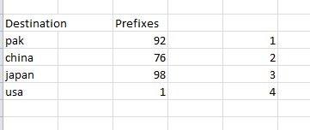

- Then copy and paste the same value(column E) two times (depending how many blank rows you need in between)
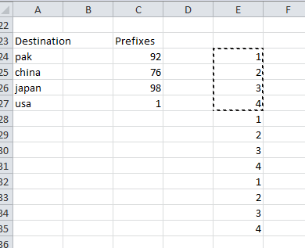
- Then select the complete table (columns A,B,C,D,E) and go to custom sort -> add level.
‘Sort by’ -> Column E, ‘then by’ Column A.

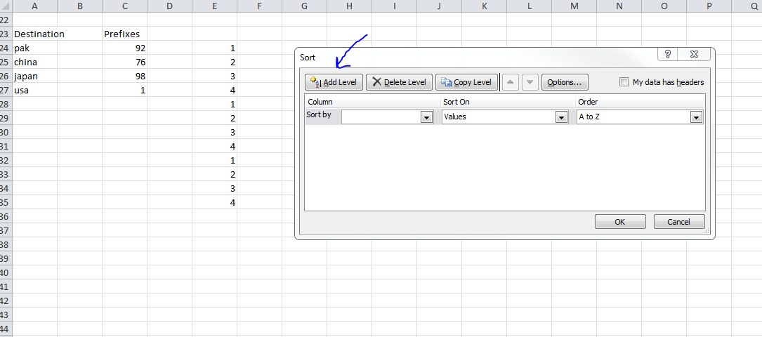

- Here you go! You will get:
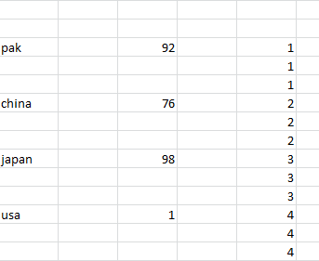

Step 2)
How to add replicate those prefixes in the blank rows respectively???
- Copy the prefixes column and make two more columns pasting the values like following indentation.

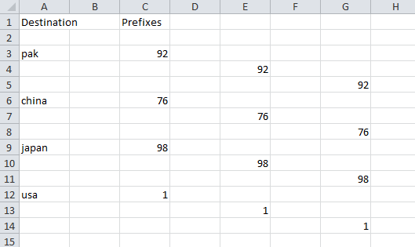

- Now we will make a function and copy and paste that too.

Start a new fresh column and write ‘= C3’ , press enter then go down on the line and type ‘=E4’ , press enter, then go down again and type ‘=g5’.

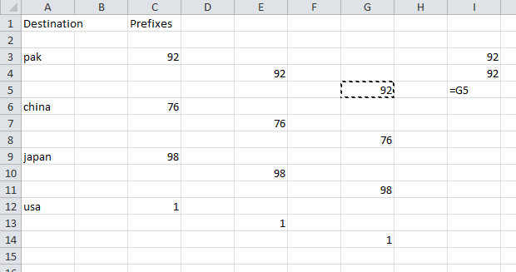

- Copy and the three cells and select the whole column and paste it!!
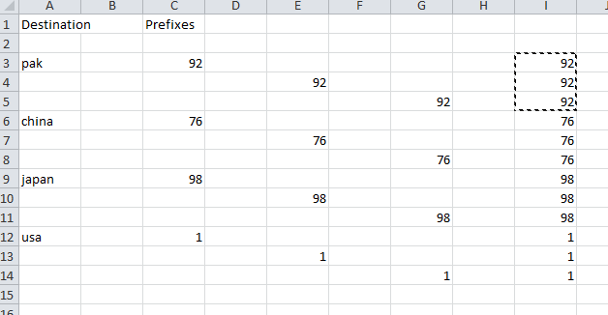

Same process you can repeat to do the priority column

- Make three columns, one fill with 0s, 2nd with 1s and 3rd with 2s having the indentation described above, and then merge the columns described above.

