- Open a blank workbook and position your mouse on D1. Then click on Get Data --.From Web.
- Complete the as shown below and click ok
- 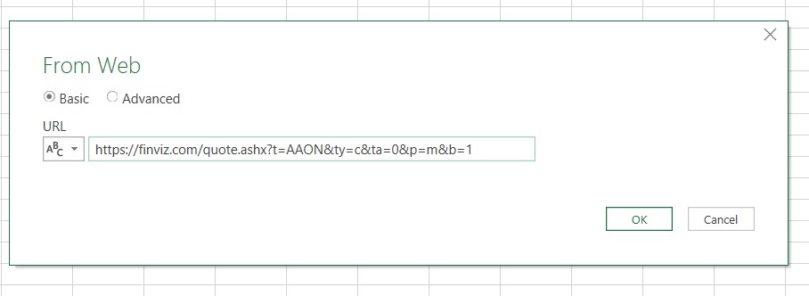
- A window will open as follows and you want to Select Table 0 and then click on Transform or Edit (they are the same only different versions).
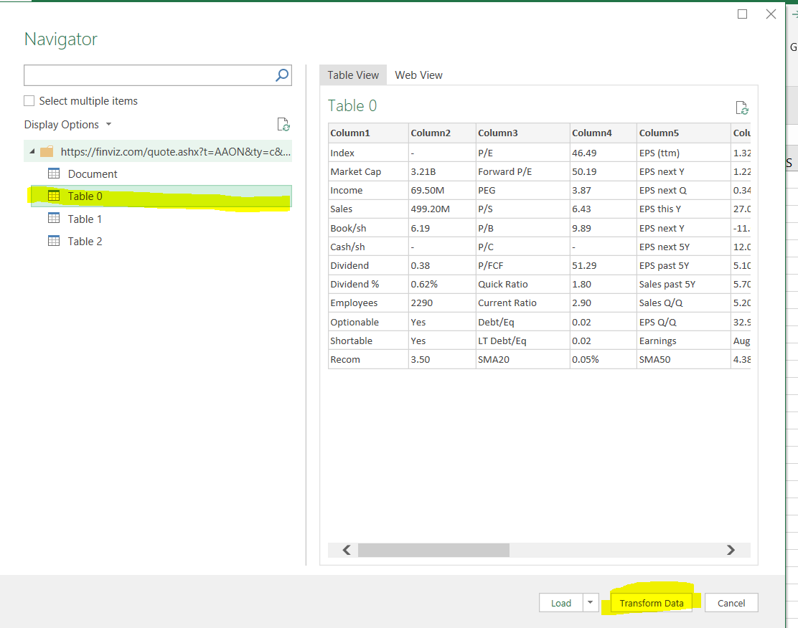
- With the PQ editor now open, click on the Home Tab and then Close and Load To. Select Table, 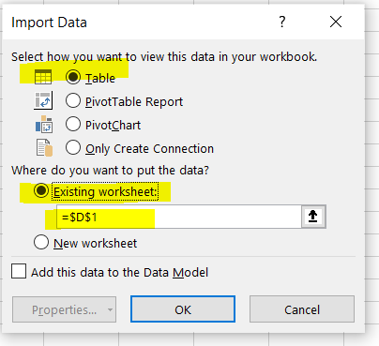
- Your table will now appear for Ticker AAON.
- Now in A1, type Path and in A2 type MO, Highlight both A1 and A2 and click on Get DataFrom Range or Table. In the window that opens make sure the check box for Has headers is checked.
- In the PQ, in the Query Settings, there is a line “Changed Type” with an X next to it. Click on the X to remove.
- Click on the View Tab and select Advanced Editor
- 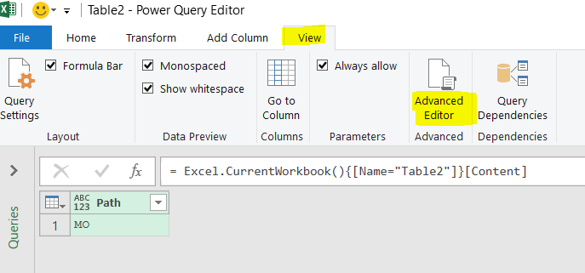
- With the Editor open, change the Mcode to look like the following: 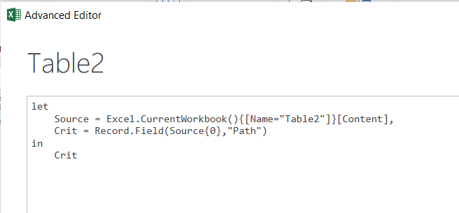
- In the Query Settings change the Name to Symbol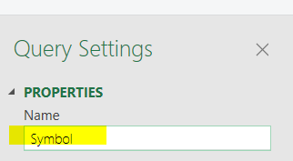
- Click on Done and then click on Close and Load To and be sure to select Connection Only.
- In Queries and Connections Window, Right click on Table 0 and select Edit. Your table will open in the PQ Editor.
- Select the View Tab and Advanced Editor
- Change the Mcode to look exactly like the shown below and highlighted. 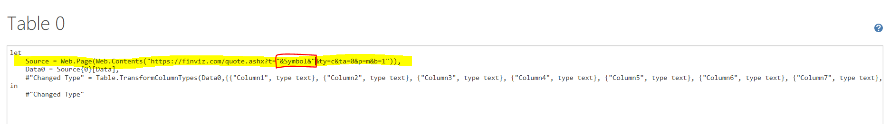
- Close and Load after completing the above step.
- In Excel, save your file.
- Whenever you type a symbol into A2, then click on Refresh to update the table at D1.

